Orange pumpkin,
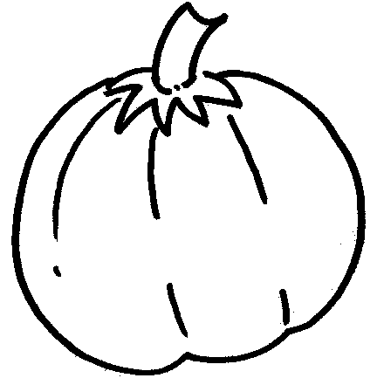
Orange pumpkin,

What do you see ?
Orange pumpkin,
Orange pumpkin,
What do you see ?

I see a brown bat looking at me.
Brown bat,
Brown bat,
What do you see?
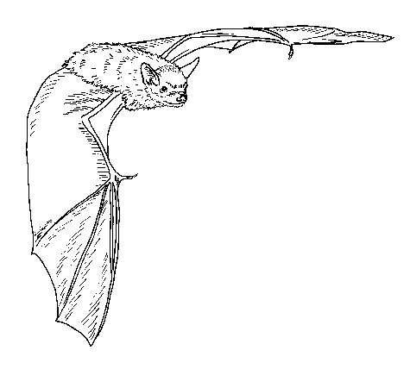

I see a yellow moon looking at me.
Yellow moon,
Yellow moon,
What do you see?
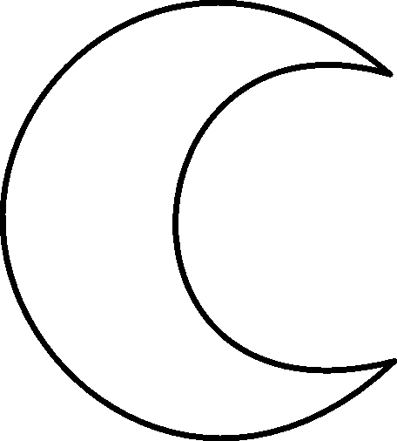

I see a blue monster
looking at me.
Blue monster,
Blue monster,
What do you see?
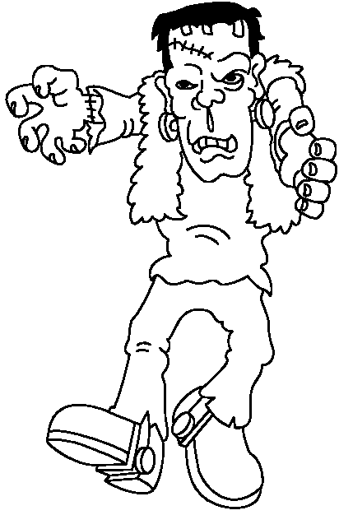

I see a black cat looking at me.
Black cat,
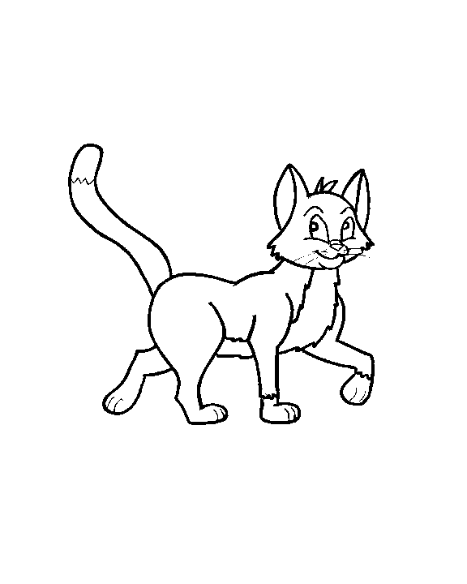
Black cat,
What do you see?

I see a green witch
looking at me.
Green witch,
Green witch,
What do you see?
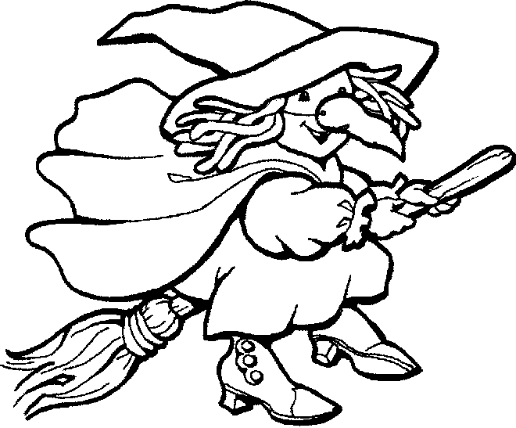

I see a white ghost
looking at me.
White ghost,
White ghost,
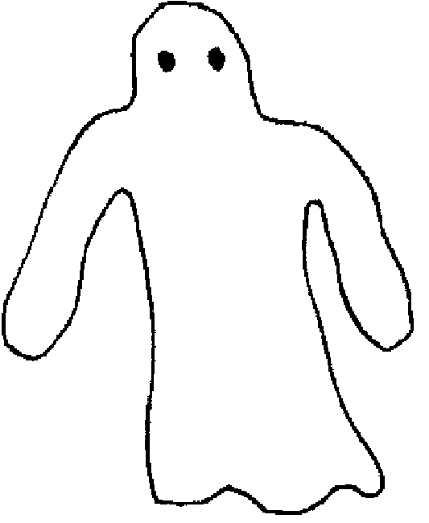
What do you see?

I see red vampire
looking at me.
Red vampire,
Red vampire,
What do you see?
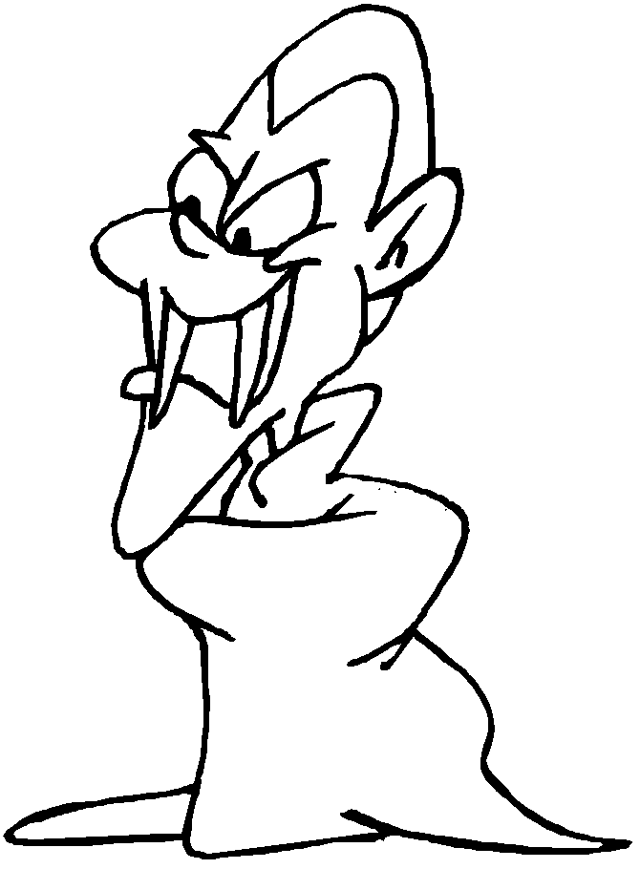

I see a purple goblin
looking at me.
Purple goblin
Purple goblin
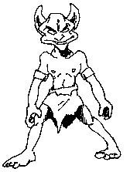
What do you see?

I see trick or treaters
looking at me.
Trick or treaters,
Trick or treaters,
What do you see?
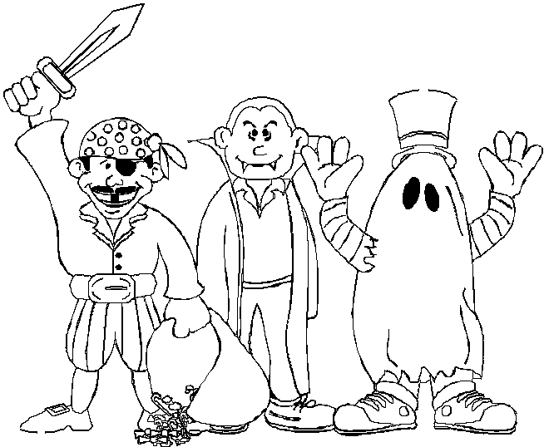

We see …

an orange pumpkin,

a brown bat,

a yellow moon,

a blue monster,
a black cat,

a green witch,
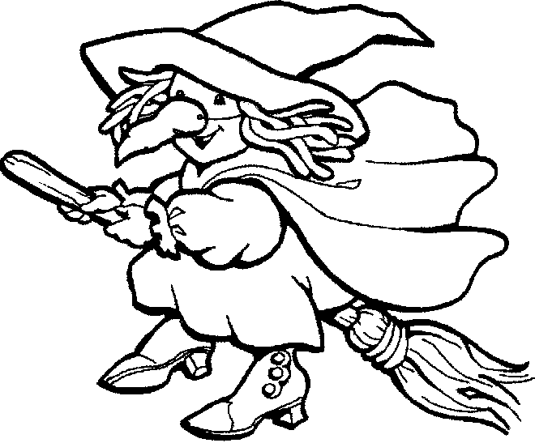

a white ghost,

a red vampire,

a purple goblin,
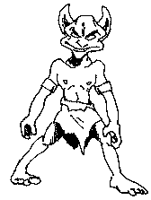

and YOU
looking at us!

That’s what we see!

